

International Shooting Sport Federation

and
USA Shooting

Edition 2011 (First Printing, 11/2008)
Effective 1 February 2011


PISTOL RULES

FOR

50 m Pistol

25 m Rapid Fire Pistol

25 m Center Fire Pistol

25 m Standard Pistol

25 m Pistol

10 m Air Pistol

CHAPTERS
8.1 GENERAL - 335 -
8.2 SAFETY - 335 -
8.3 RANGE AND TARGET STANDARDS - 335 -
8.4 EQUIPMENT AND AMMUNITION - 335 -
8.5 ACCESSORIES - 339 -
8.6 SHOOTING EVENT PROCEDURES AND COMPETITION RULES - 339 -
8.7 MALFUNCTIONS - 348 -
8.8 PISTOL EVENT TABLE - 355 -
8.9 PISTOL SPECIFICATION TABLE - 356 -
8.10 DRAWINGS AND MEASUREMENTS - 357 -
8.11 INDEX PISTOL RULES - 359 -

Note: Where figures and tables contain specific information, these have the same authority as the numbered rules.

  - GENERAL
    - These Rules are part of the Technical Rules of the ISSF and apply to all pistol events.
    - All shooters, team leaders and officials must be familiar with the ISSF Rules and must ensure that these Rules are enforced. It is the responsibility of each shooter to comply with the Rules.
    - When a Rule refers to right-handed shooters, the reverse of that Rule refers to left-handed shooters.
    - Unless a Rule applies specifically to a men's or a women's event, it must apply uniformly to both men's and women's events.
  - SAFETY
Safety is of paramount importance
See Technical Rules – Section 6.
  - RANGE AND TARGET STANDARDS
Target and range standards may be found in the Technical Rules Section 6.
  - EQUIPMENT AND AMMUNITION
    - Standards for all Pistols
      - Grips. For dimensions and details of grips see the Pistol Specification Table and Table for Drawing and Measurements.
        - Neither the grip nor any part of the pistol may be extended or constructed in any way that would allow it to touch beyond the hand. The wrist must remain visibly free when the pistol is held in the normal firing position. Bracelets, wristwatches, wristbands, or similar items are prohibited on the hand, and arm, which holds the pistol.
        - Adjustable grips are permitted providing when adjusted for the shooter's hand they conform to the rules for the event. The adjustment must not be changed after the Equipment Control checks in any way that would conflict with the ISSF Rules.
      - Barrels: see the Pistol Specification Table.
      - Sights: see the Pistol Specification Table.
Only open sights are allowed. Optical, mirror, telescope, laser-beam, electronically projected dot sights etc., are prohibited. Any aiming device programmed to activate the firing mechanism is prohibited. No protective covering is permitted on front or rear open sights.
        - Correcting lenses and/or filters must not be attached to the pistol.
        - Correction glasses and/or filters may be worn by the shooter.
      - Electronic Triggers are allowed providing:
        - all their components are firmly attached to and contained within the frame or grip of the pistol;
        - the trigger is operated by the hand that holds the pistol;
        - all components are included when the pistol is submitted for inspection by the Equipment Control Section;
        - the pistol with all components installed complies with the rules governing dimensions and weight for that event.
      - Case Catchers are allowed providing the pistol complies with all the Rules (dimensions and weight) when fitted. This must be marked on the Equipment Control Card by the Equipment Control Section.
      - Measuring the Weight of the Trigger Pull
Metal knife-edge

Rubber knife-edge
        - Note:
A weight with a metal knife-edge or with rubber must be used. A roller on the trigger weight is not permitted. A dead weight must be used with no springs or other devices.
        - Measuring the Weight of the Trigger Pull
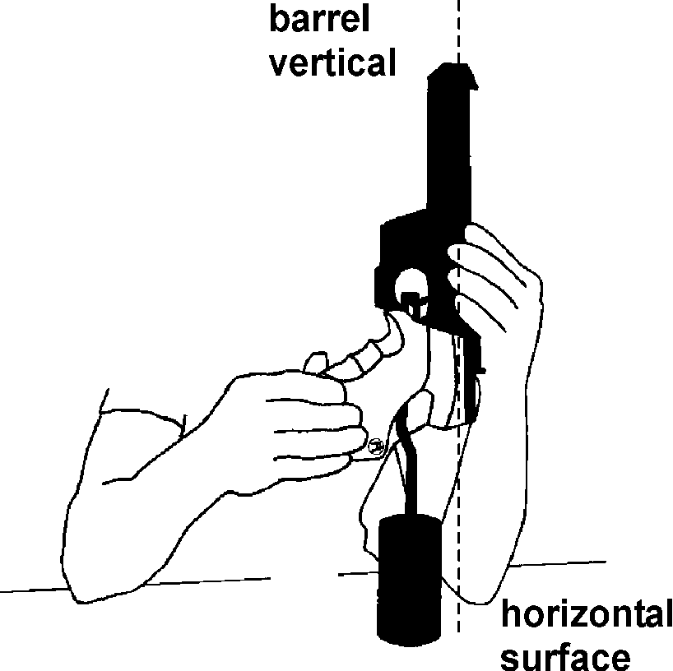
The weight of the trigger pull must be measured, with the test weight suspended near the middle of the trigger (see illustrations) and the barrel held vertically. The weight must be placed on a horizontal surface and lifted clear of the surface. The tests must be conducted by Equipment Control officials. The minimum weight of the trigger pull must be maintained throughout the competition. A maximum of three (3) attempts to lift the weight is allowed. If it does not pass it may only be resubmitted after adjustment. When testing air or gas actuated pistols, the propellant charge should be activated.

        - The appropriate trigger test weight that may be used for random checks will also be made available to the shooters on the range before and during the competition, and before the Finals, to allow them to check that the weight of the trigger pull has not changed so as to contravene the Rules.
        - Random Trigger Weight control checks must be conducted immediately after the last series in all qualification rounds of 10 m and 25 m events. At least one shooter should be selected from each Range Section (or eight firing positions for Air Pistol) by drawing of numbered lots by the Range Jury. Equipment Control Officers must then conduct the tests before pistols are returned to their cases. A maximum of three (3) attempts to lift the weight is allowed. Any shooter whose pistol fails this test or when a shooter is selected fails to undertake the test, he must be disqualified.
    - Specific Standards for 25 m Pistols
The Shooter must use the same pistol in all stages and series of an event unless it ceases to function.
      - The center line of the bore must pass above the web (between thumb and forefinger) of the hand holding the pistol in the normal firing position.
      - The barrel length is measured as follows (see the Pistol Specification Table).
Semiautomatic | From the muzzle to the breech face (barrel plus chamber).
Revolver | Barrel only (excluding cylinder).
      - 25 m Rim Fire Pistol
Any caliber 5.6 mm (.22”) rim fire pistol, chambered for Long Rifle cartridges, except single shot, may be used, that conforms to the Pistol Specification Table.
      - 25 m Center Fire Pistol
Any Center Fire Pistol, except single shot, of caliber 7.62 mm to 9.65 mm (.30” - .38”) may be used, that conforms to the Pistol Specification Table.
    - 50 m Pistol
Any caliber 5.6 mm (.22”) rim fire pistol, chambered for Long Rifle cartridges, may be used.
USA 8.4.1A In USA Shooting sanctioned competitions, a pistol equipped with a magazine may be used but it may only be loaded with one cartridge at a time.
      - Hand covers for 50 m Pistol are permitted, providing they do not cover the wrist.
    - Ammunition
All projectiles used must be made of lead or similar soft material only. Jacketed projectiles are not permitted. The Jury may take samples from the shooter’s ammunition for checking.
Pistol | Caliber | Other specifications
10 m Air Pistol | 4,5 mm (.177”)
25 m Center Fire Pistol | 7.62 mm – 9.65 mm (.30”-.38”) | High power and Magnum ammunition are not allowed.
50 m Pistol | 5.6 mm (.22”) | Rim Fire Long Rifle.
25 m Rim Fire Pistol | 5.6 mm (.22”) | Rim Fire Long Rifle  For the Rapid Fire Pistol Event: minimum bullet weight 2.53g = 39gr; minimum velocity 250 m/sec – measured 2 m from the muzzle. A chronograph (velocity measurement device) must be available to shooters on the range.
    - Clothing Regulations
      - During all Training and Competitions:
        - Women are required to wear dresses, skirts, divided skirts, shorts or trousers, and blouses or tops (which will cover the front and back of the body, and be over each shoulder).
        - Men are required to wear full-length trousers or shorts and long or short sleeved shirts.
        - Shorts may not be shorter than the athlete’s fingertips when the arms and fingers are extended at the athlete’s side.
        - Sweaters or cardigans may be worn.
        - Tracksuits supplied to the team as official uniform will be permitted.
        - All members of one team, men or women, should be dressed in a similar team top.
      - Only low-sided shoes which do not cover the ankle bone are permitted.
  - ACCESSORIES
    - Spotting Telescopes
The use of telescopes not attached to the pistol to locate shots or judge the wind is permitted for 25 m and 50 m events only.
USA 8.5.1A The use of telescopes not attached to the pistol to locate shots or judge the wind is permitted for all pistol events.
  - SHOOTING EVENT PROCEDURES AND COMPETITION RULES
    - Position
      - The shooter must stand free, without support, with both feet and/or shoes completely within the firing point. The pistol must be held and fired with one hand only. The wrist must be visibly free of support.
      - In the 25 m Rapid Fire Pistol Event, the 25 m Pistol and 25 m Center Fire Pistol Rapid Fire Stages and the 25 m Standard Pistol 20 seconds and 10 seconds series, shooting must start from the READY position. In the READY position, the shooter's arm must point downward at an angle of not greater than 45 degrees from the vertical, but must not be pointed at the ground within the forward edge of the firing point. The arm must not be visibly moving in this position while waiting either for the appearance of the target or, when electronic scoring targets are used, for the green light(s) to come on.
      - The READY Position
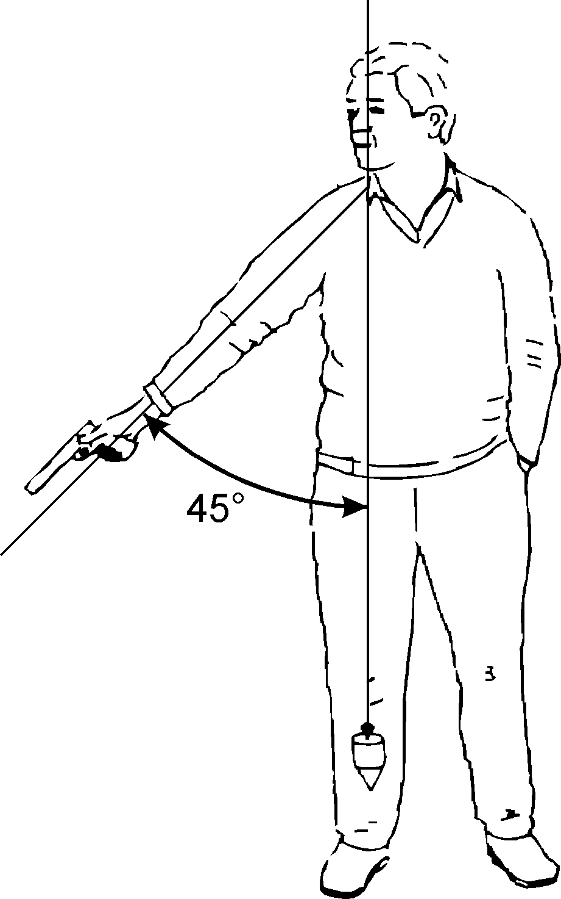
      - If a shooter raises his arm too soon, or does not lower it sufficiently in the 25 m Rapid Fire Pistol Event or in the Rapid Fire Stage of the 25 m Pistol or 25 m Center Fire Pistol Event, or in the combined 20 seconds and 10 seconds stages of the 25 m Standard Pistol Event he must be warned by a Jury Member, and the series must be recorded and repeated. In the 25 m Rapid Fire Pistol Event the shooter must be credited with the lowest value hit on each target. In all other 25 m events, the shooter must be credited with the five (5) lowest value hits in the two series (or three series should a malfunction be involved). If the fault is repeated in the same stage of 30 shots the same procedure must be applied and the shooter must be penalized by a deduction of two (2) points from his score. If a third infringement of this Rule occurs, the shooter must be disqualified.
    - Pistol Events
    - See the Pistol Event Table
    - Competition Rules
      - Preparation Time 25 m Events
        - Shooters should report at their Range Section, but wait to be called forward to the firing points. Time permitting, before the commencement of the Preparation Time, the shooters will be called to the firing points where they may set up their equipment and handle their pistols providing any preceding relay has finished. Pre-competition checks by the Jury and Range Officers must be completed before the Preparation Time starts.
        - Then they will be given the command “PREPARATION TIME BEGINS NOW”. During the Preparation Time the targets must be visible, facing the shooters. During the Preparation Time the shooters may dry fire and carry out holding and aiming exercises on the firing line.
        - Preparation Time allowed before the competition starts is as follows:
25 m Standard Pistol | 5 minutes
25 m Precision Stages | 5 minutes
25 m Rapid Fire Stages or Events | 3 minutes
      - 25 m Events
        - In all 25 m Events, timing must start at the moment the green lights come on (or the targets begin to face) and stop when the red lights come on (or the targets begin to turn away).
        - The turning of the targets or the switching of lights may be controlled by a Target Operator who is located behind the firing line. His position must not disturb the shooter, but it must be within the sight and hearing of the Range Officer. The targets may also be operated by the Range Officer by means of a remote control system.
USA 8.6.4.2.2A In USA Shooting sanctioned PTO’s, audible start and stop signals may be used. Please see rule 6.3.16.9C
        - LOAD
In all 25 m events, only one (1) magazine or pistol may be loaded with not more than five (5) cartridges on the command “LOAD”. Nothing else is allowed to be inserted into the magazine or cylinder.
          - If a shooter loads his pistol with more than a total of five (5) cartridges or he loads more than one (1) magazine on any command “LOAD” he must be penalized by the deduction of two (2) points, for each additional cartridge, from his competition score in that same series.
          - A shot or shots fired before the command “LOAD” must incur disqualification.
        - UNLOAD
In all events, after the series or stage has been completed, the command “UNLOAD” must be given. In any case, immediately upon completing a series (unless there is a malfunction of the pistol), or when ordered, the shooter must unload the pistol.
      - Specific Rules for the 25 m Rapid Fire Pistol Event
The event is 60 competition shots divided into two stages of 30 shots each. Each stage is subdivided into six (6) series of five (5) shots each, two (2) in eight (8) seconds, two (2) in six (6) seconds and two (2) in four (4) seconds. In each series one (1) shot is fired at each of the five (5) targets in the specified time limit for the series.
        - Before the beginning of each stage, the shooter may fire one (1) sighting series of five (5) shots in eight (8) seconds.
        - All shooting (sighting and competition series) is by command. Both shooters in the same Range Section must fire at the same time, but organizers may arrange for more than one Range Section to fire simultaneously under centralized commands.
        - If a pistol of any of the shooters firing together has a malfunction, the malfunction series must be re-fired by those concerned in the same time stage with the following regular series. The final series of this stage will be fired immediately after all other shooters firing together have completed this time stage. Each Range Section may operate independently.
        - Before the Range Officer gives the command “LOAD”, he must call out the series time (such as “eight (8) seconds series, or six (6) seconds series”, etc.), or the series time must be indicated in some manner such as using a numbered sign of sufficient size to be visible to the shooter. When the Range Officer gives the command “LOAD”, the shooters must prepare themselves immediately for their series within one (1) minute.

        - When one (1) minute has expired, the Range Officer will give the commands:
“ATTENTION” | The red lights must be switched on or if paper targets are used, they must be turned to the edge-on position.
“3-2-1-START” | At the Command “START” the target timer mechanism must be started. The shooters must be in the READY position by the count-down of 1.
        - Before each series the shooter must lower his arm and adopt the READY position.
        - The targets must then face the shooter, or the green lights come on, after a delay of three (3) seconds (± 1.0 second). The time delay should remain constant throughout the competition. During each series the shooter should fire five (5) shots. Pistols may be raised at the moment the targets begin to face, or the green lights come on.
        - A series is considered as having started after the command “ATTENTION”. Every shot fired after that will be counted in the competition.
        - After the firing of each series, there should be a pause of at least one (1) minute before the next command “LOAD”. The published start time for successive relays should be adequate to allow for these relays to start at the published time. 30 minutes should be the minimum time between the start of successive relays and longer if the program permits.
      - Specific Rules for 25 m Pistol and 25 m Center Fire Pistol
The program for each event is 60 competition shots divided into two (2) stages of 30 shots each:
Stage | Number of  series / shots | Time limit for each  series competition  and sighting
1. Precision Stage | six (6) series of five  (5) shots | five (5) minutes
2. Rapid Fire Stage | six (6) series of five  (5) shots | see below
        - Before the beginning of each stage, the shooter may fire one (1) sighting series of five (5) shots.
        - Precision Stage
          - The Range Officer must give the command “LOAD”. After the command “LOAD”, the shooter(s) must prepare themselves within one (1) minute with the correct number of cartridges. Firing will begin on the appropriate command or signal.
          - All shooters must complete the Precision Stage before the Rapid Fire Stage may begin.
        - Rapid Fire Stage
          - During each series the target is shown five (5) times or, when electronic scoring targets are used, the green lights come on each time for three (3) seconds (+ 0.2 seconds – 0.0 second). The time between each appearance (the edge-on position) or, when Electronic Scoring Targets are used, the red lights are on must be seven (7) seconds (±0.1 second). One (1) shot only will be fired during each “appearance” of the target.
          - all shooters will fire the sighting series as well as the competition series at the same time and on the same commands:
“FOR THE SIGHTING SERIES – LOAD” | All shooters load within a time of one (1) minute.
“FOR THE FIRST / NEXT COMPETITION SERIES – LOAD” | All shooters load within a time of one (1) minute.
“ATTENTION” | The red lights must be switched on or if paper targets are used, they must be turned to the edge-on position After a delay of seven (7) seconds (+/-1.0 second) either the green lights will come on, or the target will be turned to face the shooter.
 | Before each shot the shooter must lower the arm and adopt the READY position.
 | The pistol must not be rested on the bench, or shooting table, during the series.
        - A series is considered as having started from the moment the red light is switched on, or the targets turn away from the shooter after the command “ATTENTION”. Every shot fired after that must be counted in the competition.
      - Specific Rules for the 25 m Standard Pistol Event
The event program is 60 competition shots divided into 3 stages of 20 shots each. Each stage consists of 4 series of 5 shots:
Stage | Number of series / shots | Time limit for each series
1 | four (4) series of five (5) shots | 150 seconds
2 | four (4) series of five (5) shots | 20 seconds
3 | four (4) series of five (5) shots | 10 seconds
        - Before the beginning of the competition, the shooter may fire one (1) sighting series of five (5) shots within a time limit of 150 seconds.
        - Before the Range Officer gives the command “LOAD”, he must call out the series time (such as 150 seconds series, or 20 seconds series etc.), or the series time must be indicated in some manner such as using a numbered sign of sufficient size to be visible to the shooter. When the Range Officer gives the command “LOAD”, the shooter(s) must prepare themselves immediately for their series within one (1) minute.
        - When one minute has expired, the Range Officer will give the command:
“ATTENTION” | The red light will be switched on, or the target will be turned away to the edge-on position. After a delay of 7 seconds (+/-1.0 second) the green light will come on, or the target will be turned to face the shooter.
        - Before each series except in the 150 second series the shooter must lower his arm and adopt the READY position.
        - A series is considered as having started from the moment the red light is switched on, or the targets turn away from the shooter after the command “ATTENTION”. Every shot fired after that must be counted in the competition.
        - When it is necessary to conduct the event in two parts, each part must consist of:
Stage | Number of series / shots | Time limit for each series
1 | two (2) series of five (5) shots | 150 seconds
2 | two (2) series of five (5) shots | 20 seconds
3 | two (2) series of five (5) shots | 10 seconds
          - Before the beginning of each part of the event, the shooter may fire one (1) sighting series of five (5) shots within a time limit of 150 seconds.
    - Interruptions
      - 25 m Events and Stages
If for safety or technical reasons shooting is interrupted (without being the fault of the shooter):
        - if the elapsed time is more than 15 minutes, the Jury must allow one (1) extra sighting series of five (5) shots;
        - in the 25 m Rapid Fire Pistol and in the 25 m Standard Pistol Event, if the series is interrupted it must be annulled and repeated. The repeated series must be recorded and credited to the shooter;
        - in the 25 m Pistol and the 25 m Center Fire Pistol Events, the interrupted series must be completed. The completed series must be recorded and credited to the shooter;
          - in the Precision Stage the time limit is one (1) minute for every shot to be fired to complete the series.
    - Irregular shots
      - 25 m Events and Stages
        - Too many shots fired
          - If a shooter fires more competition shots on a target than the program calls for, or more than one shot at one appearance of the target in a Rapid Fire Pistol Series, the highest value hit(s) must be disregarded from the score of that target. Two (2) points must also be deducted from the score of that series for each extra shot fired in the series. This penalty is in addition to the penalty of two (2) points that may be imposed when a shooter loads more than five (5) cartridges.
          - Two (2) points must be deducted on every occasion if two shots are fired during a single exposure of the target in the Rapid Fire stages of the 25 m Pistol and the 25 m Center Fire Pistol Events.
          - If a shooter fires more sighting shots than are provided for in the program, or are approved by the Range Officer or Jury, he must be penalized by the deduction of two (2) points from the first series of his competition score for each excessive sighting shot fired. This penalty is in addition to the penalty of two (2) points that may be imposed when a shooter loads more than five (5) cartridges.
      - Early and late shots
        - Any shot(s) fired accidentally after the command “LOAD” has been given, but before the beginning of a competition series, must not be counted in the competition but two (2) points must be deducted from the following series. This penalty must not apply in the sighting series. The shooter having fired accidentally must not continue, but must wait until the other shooters have finished that series and then indicate to the Range Officer as if he had a malfunction. The Range Officer will then permit him to continue and repeat the series in the same time stage with the following regular series. The final series of the stage will be fired immediately after all shooters have completed that time stage. If this procedure is not followed and the shooter continues the original series, the accidentally fired shot will be scored as a miss (zero).
        - In a Precision Stage, if a shot(s) is fired after the command or signal “STOP”, that shot must be counted as a miss. If the shot(s) cannot be identified the highest value hit(s) must be deducted from the score of that target and scored as miss(es).
      - Incorrect Range Commands 25 m Events
        - If, because of an incorrect command and/or action by a Range Officer, the shooter is not ready to fire when the signal to fire is given, he must hold his pistol pointing down range and raise his free hand, and immediately after the series report this to a Range Officer or Jury Member.
        - If the claim is considered justified, the shooter must be allowed to fire the series.
        - If the claim is considered not justified, the shooter may fire the series, but must be penalized by the deduction of two (2) points from the score of that series.
        - If the shooter has fired a shot after the incorrect command and/or action, the protest must not be accepted.
      - Cross-fires on sighting targets
        - 25 m Events and Stages
          - If a shooter fires a sighting shot on the sighting target of another shooter, he must not be allowed to repeat the shot, but will not be penalized. If it cannot be established clearly and quickly which hit(s) belong to whom, the shooter who is not at fault has the right to repeat the sighting shot(s).
    - Disturbances
Should a shooter consider that he was disturbed while firing a shot, he must hold his pistol pointing down range and immediately inform the Range Officer or Jury Member by raising his free hand. He must not disturb other shooters.
      - If the claim is considered justified:
        - the series (25 m Rapid Fire Pistol, 25 m Standard Pistol), must be annulled and the shooter may repeat the series;
        - the shot (25 m Pistol and 25 m Center Fire Pistol) must be annulled and the shooter may repeat the shot and complete the series.
      - If the claim is considered not justified:
        - if the shooter has finished his series, the shot or series must be credited to the shooter;
        - if the shooter has not finished his series due to the claimed disturbance, the shooter may repeat or complete the series. Scoring and penalties are as follows:
          - in the 25 m Rapid Fire Pistol Event the series may be repeated and the score must be recorded as the total of the lowest value hit on each target;
          - in the 25 m Standard Pistol Event the series may be repeated and the score must be recorded as the total of the five (5) lowest value hits on the target;
          - in the 25 m Pistol and 25 m Center Fire Pistol Events the series may be completed and the score must be recorded;
          - two (2) points must also be deducted from the score of the repeated or completed series;
          - in any repeated series, all five (5) shots must be fired at the target. Any shot(s) not fired or not hitting the target must be scored as a miss(es).
    - Timing
If a shooter considers that the time elapsed between the command specified in the Rules and the green light coming on or the facing of the targets was too fast or too slow, and therefore not according to the time specified in the Rules, he must hold his pistol pointing down range and immediately inform a Range Officer or Jury Member by raising his free hand. He must not disturb other shooters.
      - If it is found that his claim is justified, he may begin the series again.
      - If his claim is found not justified, he may fire the series, but a two (2) point penalty must be deducted from the score of that series.
      - Once the shooter has fired the first shot in the series, such a claim must not be accepted.
      - If a shooter considers that the time of the series was too short, he may inform a Range Officer immediately after finishing the series.
        - The Range Officer and/or Jury must verify the timing of the mechanism.
        - If it is confirmed that there has been an error, the protesting shooter‘s series must be annulled and repeated.
        - If the claim is considered not justified, the result of the series must be credited to the shooter and recorded.
  - MALFUNCTIONS
Only one (1) malfunction (either allowable or non allowable) is permitted except when stipulated in a specific event.
    - General
Should a pistol break down or cease to function, the shooter is allowed to repair the pistol.
    - In all cases the Range Officers or Jury must be informed so they may decide on the measures to be taken.
    - 25 m Pistol Events
      - A shooter is allowed a maximum of 15 minutes to repair or replace a pistol in order to resume the competition.
      - If the repair is likely to take more than 15 minutes, the shooter, at his request, may be granted more time by the Jury.
      - If extra repair time is granted he will complete the competition at a time and place determined by the Jury or,
      - he may continue to fire with another pistol of the same type of mechanism (semiautomatic or revolver) and of the same caliber.
      - If a substitute pistol is used it must have been approved by the Equipment Control Section.
      - In the 25 m events the Jury must allow one (1) extra sighting series of five (5) shots.
    - 25 m Pistol Events Malfunctions
      - If a shot has not been fired due to a malfunction, and if the shooter wishes to claim a malfunction, he must hold his pistol pointing down range, retain his grip, and immediately inform a Range Officer by raising his free hand. He must not disturb other shooters.
        - A shooter may try to correct a malfunction and continue the series, but after attempting any correction, he may not claim an Allowable Malfunction unless the firing pin has broken, or any other part of the pistol is damaged sufficiently to prevent the pistol from functioning.
      - If a Malfunction (allowable or nonallowable) occurs in the sighting series it must not be registered as a malfunction. If an Allowable Malfunction occurs the shooter may complete the sighting series by shooting the unfired shots in the specified time for the sighting series for that event; fired immediately. In precision stages the unfired shots may be fired immediately, in a maximum of two (2) minutes. If a Non-Allowable Malfunction occurs in the sighting series no further sighting shots may be fired.
      - Types of Malfunctions
        - Allowable malfunctions (AM) are:
          - a bullet is lodged in the barrel;
          - the trigger mechanism has failed to operate;
          - there is an undischarged cartridge in the chamber and the trigger mechanism has been released and operated;
          - the cartridge case has not been extracted or ejected; this applies even if a case catcher is used;
          - the cartridge, magazine, cylinder, or other part of the pistol has jammed;
          - the firing pin has broken, or any other part of the pistol is damaged sufficiently to prevent the pistol from functioning;
          - the pistol fires automatically without the trigger being released. The shooter must stop firing immediately and must not continue to use such a pistol without the permission of a Range Officer or a Jury Member. When using EST the first shot will be scored by the system and this will be credited to the shooter. When using paper targets should the automatically fired shot(s) hit the target, the hit(s) found highest up on the target shall be disregarded before the repeat series. After any repeat series all the shot(s), except those that were disregarded on the one target concerned, must be included to establish the score;
          - the slide jams or the empty case is not ejected, this applies even if a case catcher is used.
        - NON-ALLOWABLE MALFUNCTIONS (NAM) are:
          - the shooter has touched the breech, mechanism or safety catch or the pistol has been touched by another person before being inspected by the Range Officer;
          - the safety catch has not been released;
          - the shooter had not loaded his pistol;
          - the shooter had loaded less cartridges than prescribed;
          - the shooter did not allow the trigger to return far enough after the previous shot;
          - the pistol was loaded with the wrong ammunition;
          - the magazine was not inserted correctly, or had fallen out during shooting unless this is due to damage to the mechanism;
          - the malfunction is due to any cause that could reasonably have been corrected by the shooter.
      - Determining the Cause of a Malfunction
If the external appearance of the pistol does not show an obvious reason for the malfunction and there is no indication, and the shooter does not claim, that there may be a bullet stuck in the barrel the Range Officer must take the pistol without interfering with or touching the mechanism, point the pistol in a safe direction and pull the trigger one time only to determine whether the trigger mechanism had been released.
        - If the pistol is a revolver, the Range Officer must not pull the trigger unless the hammer is in the cocked position.
        - If the pistol does not discharge, the Range Officer must complete the examination of the pistol to determine the cause of the malfunction and to decide whether or not the malfunction is allowable.
      - The Range Officer decides, after inspection of the pistol, that there is an ALLOWABLE MALFUNCTION or a NON-ALLOWABLE MALFUNCTION.
        - In the case of a NON-ALLOWABLE MALFUNCTION every shot that is not fired will be scored as a miss (zero). No re-fire or completion is permitted. Only the values of shots fired will be credited to the shooter. The shooter may continue to shoot the remainder of the event.
        - In the case of an ALLOWABLE MALFUNCTION the following procedures will be followed.
          - 25 m Rapid Fire Pistol, 25 m Standard Pistol
            - The number of shots already fired must be recorded and the series may be repeated.
            - The shooter must fire all five (5) shots at the target(s) in any repeat series. Any shot(s) not fired or not hitting the target in the re-fire must be scored as zero(s). Should a second malfunction occur, then the shooter may not re-fire again (but unfired shots must NOT be scored as zero(s). The shooter may continue to shoot the remainder of the event.
            - Scoring: ALLOWABLE MALFUNCTION
            - 25 m Rapid Fire Pistol: The score must be recorded as the total of the lowest value hit on each target in the two (2) series.
            - 25 m Standard Pistol: The score must be recorded as the total of the five (5) lowest value hits on the target.
            - If the shooter is unable to complete a full series in the one (1) permitted re-shoot, he must be credited only with as many of the lowest value hit(s) as the highest number of shots he has fired in the series or in the repeat series.
          - 25 m Pistol and 25 m Center Fire Pistol
Precision Stage and Rapid Fire Stage:
            - the number of shots is recorded and the series may be completed;
            - shot(s) to complete the series must be fired in the immediately following series (in the Precision Stage a time of one (1) minute will be allowed for each shot to be fired) or starting on the first exposure (Rapid Fire Stage).
            - Any shot(s) not fired or not hitting the targets must be scored as miss(es) (zero(s)).
            - The five shot series must be scored in the normal manner.
        - All 25 m Pistol Events
An allowable malfunction may be claimed:
          - once in each 30 shot stage of the 25 m Rapid Fire Pistol, 25 m Pistol and 25 m Center Fire Pistol events;
USA
8.7.4.5.3.1A At USA Shooting team selection matches only, up to 2 malfunctions may be allowed in each 30 shot stage of the 25m Rapid Fire and 25m Pistol events, provided it is stated clearly in the match program prior to the event.
          - once in the 150 seconds stage and once in the combined twenty (20) seconds and ten (10) second stages of the 25 m Standard Pistol event.
        - Interrupted series (after an Allowable Malfunction) in the 25 m Pistol Events will be repeated or completed in the same time stage with the following regular series. The final series of this stage will be fired immediately after all other shooters have completed that time stage.
      - In all cases, when scoring malfunctions, the appropriate form (A,B,C or D) must be used. For the forms to be used, see Technical Rules before the Index.
    - Failure of Electronic Scoring Target Systems or Paper Target Systems
      - In the event of a failure of ALL the targets on a range:
        - the expired shooting time must be recorded by the Chief Range Officer and the Jury;
        - all completed competition shots of each shooter must be counted and recorded. In the event of a range power supply failure, this may involve waiting until power is restored to enable the number of shots registered by the target, not necessarily on the firing point monitor, to be established.
      - Failure of 25 m Electronic Scoring Target Systems
        - After the target is repaired and the full range, or Range Section, is in operation, an additional sighting series and a one (1) minute pause will be given before the start of the completion of the series in accordance with the rules below.
        - 25 m Pistol and 25 m Center Fire Pistol Events
          - The shooter will COMPLETE the series of five shots in the same way as for an Allowable Malfunction. The shooter should fire the number of shots that had not been recorded by the target when the failure occurred.
        - 25 m Standard Pistol and 25 m Rapid Fire Pistol Events
          - If the series was NOT completed and recorded, it will be ANNULLED and REPEATED. If the five (5) shots were recorded for any shooter, the series score will be recorded and no repetition will be permitted by that shooter.
        - Failure of a Single Target
          - If there is a failure of a single target or a group of five targets (25 m Rapid Fire Pistol Event) the shooter will be moved to another firing position in the same, or if necessary, a following relay. After the problem is resolved, a separate sighting series and a one (1) minute pause will be given before the firing of the next series in accordance with the rule above.
        - Complaint concerning failure to register or display a shot on the monitor(s) of 25 m Electronic Scoring Target systems, or it shows a zero that was not expected.
          - In the Precisions Stages of 25 m Pistol and 25 m Center Fire Pistol Events and in the 150 seconds series of the 25 m Standard Pistol Event, the shooter must immediately (before the next shot) inform the nearest range official of the failure.
            - The shooter will then be directed to complete the series in a time decided by the Jury.
          - In the Rapid Fire Stages of 25 m Pistol and 25 m Center Fire Pistol Events and in the Rapid Fire Stages of the 25 m Standard Pistol Event, the shooter must continue the five (5) shot series and must inform the nearest range official of the failure immediately after the end of the series.
            - There will be no repeated series. The score will be determined by the Classification Jury.
          - After the series has been completed, the Procedure for Examination for Electronic Scoring Targets will be applied.

  - PISTOL EVENT TABLE
Event | Men/  Women | Number of shots | Number of shots per competition target (paper only) | Number of sighting targets (paper only) | Number of sighting shots | Scoring and  Patching Paper Targets | Time | PreparationTime
10 m Air Pistol | Men Women | 60  40 | 1 | 4 | unlimited before the competition shots | In the Classification Office | 1 hour, 45 minutes  1 hour, 15 minutes | 10 minutes
50 m Pistol | Men | 60 | 5 | 2 | unlimited before the competition shots | In the Classification Office | 2 hours | 10 minutes
25 m Rapid Fire Pistol | Men | 60 | 1  New targets for each shooter for each stage  (5+30 shots) | 5 | 1 series of 5 shots in each stage | After every  5 shot series | 2 stages of 30 shots of 2 five-shot-series in 8, 6, 4 seconds | 3 minutes
25 m Pistol | Women | 60 | 5  New target after the first 15 competition shots in Rapid Fire Stages  and for each five shots series of the precision stages | 1 | 1 series of 5 shots in each stage | After every  5 shot series | Precision stage: 30 shots of 6 five-shot-series in 5 minutes Rapid fire stage: | Precision stage:  5 minutes  Rapid fire
25 m Center Fire Pistol | Men | 60 |  |  |  |  | 30 shots of 6 five-shot-series in the rapid fire program | Stage:  3 minutes
25 m Standard Pistol | Men | 60 |  |  | 1 series of 5 shots in 150 seconds stage only |  | 4 five-shot-series in 150, 20, 10 seconds | 5 minutes
  - PISTOL SPECIFICATION TABLE
Pistol Type | 1) Pistol Weight  2) Trigger Pull | Measuring Box (mm) | Barrel Length  Sight Radius | Grips | Other specifications
10 m Air Pistol | 1) 1500 g max.  2) 500 g min. | 420 x 200 x 50 | Box Size Only | See below | May only be loaded with one (1) pellet. Ported barrels and perforated barrel attachments are allowed.
50 m Pistol | 1) No Restriction  2) No Restriction | No Restriction | No Restriction  No Restriction | Special grips are permitted | May only be loaded with one (1) cartridge.  Hand covers will be permitted, providing they do not cover the wrist.
25 m Rim Fire  Pistol | 1) 1400 g max.  2) 1000 g min. | 300 x 150 x 50 | max. 153 mm  max. 220 mm | See below | Compensators, muzzle brakes, perforated barrels or any device(s) functioning in a similar manner are not allowed.
25 m Center Fire Pistol | 1) 1400 g max.  2) 1000 g min.
a) 10 m Air Pistol Grips: No part of the grip, frame or accessories may touch any part of the wrist. The heel rest must extend at an angle of not less than 90 degrees to the grip. This applies to the heel rest in front and behind the grip as well as on the sides. Any upward curvature of the heel and/or thumb rest and/or a downward curvature of the side opposite the thumb is prohibited. The thumb rest must allow free upward movement of the thumb. The grip must not encircle the hand. Curved surfaces on the grips or frame, including the heel and/or thumb rest, in the longitudinal direction of the pistol are permitted.
b) 25 m Pistol Grips: Note a) applies. In addition, the rear part of the frame or grip which rests on top of the hand between the thumb and the forefinger, must not be longer than 30 mm. This distance is measured at a right angle to the extended center line of the bore.
c) The weight of the pistol is measured with all accessories, including balancing weights and unloaded magazine.
d) Measuring Box: The pistol is measured with all accessories in place (if an Air Pistol is used with a magazine it may be measured with the magazine removed). A manufacturing tolerance of the rectangular Measuring Box of 0.0 mm to + 1.0 mm in each dimension is permitted.

  - DRAWINGS AND MEASUREMENTS
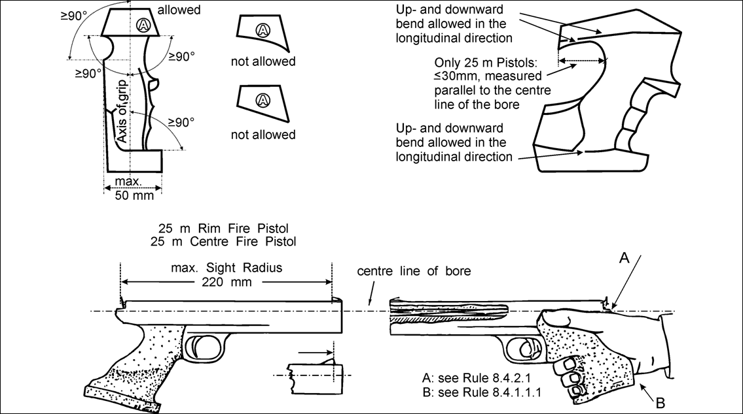

  - INDEX PISTOL RULES
25 m Events | 8.6.4.2
25 m Events – Allowable Malfunctions | 8.7.4.3.1
25 m Events – Claim a Malfunction | 8.7.4.1
25 m Events – Control of timing | 8.6.4.2.2
25 m Events – Correct a Malfunction | 8.7.4.1.1
25 m Events – Determination the cause of a Malfunction | 8.7.4.4
25 m Events – Determination: Allowable / Non Allowable Malfunction | 8.7.4.5
25 m Events – Early and late shots | 8.6.6.2
25 m Events – Early and late shots – Deduction of points | 8.6.6.2.1
25 m Events – Fire before the command “LOAD” | 8.6.4.2.3.2
25 m Events – Incorrect Range Commands | 8.6.6.3
25 m Events – Interruptions more than 15 minutes | 8.6.5.1.1
25 m Events – Irregular shots | 8.6.6.1
25 m Events – Load | 8.6.4.2.3
25 m Events – Load with more than 5 cartridges | 8.6.4.2.3.1
25 m Events – Malfunction | 8.7.4
25 m Events – Malfunction during the sighting series | 8.7.4.2
25 m Events – Malfunction: Interrupted series | 8.7.4.5.4
25 m Events – Malfunction: Number of repeating / completing a series | 8.7.4.5.3
25 m Events – Non Allowable Malfunctions | 8.7.4.3.2
25 m Events – Range Commands – Deduction of points | 8.6.6.3.3
25 m Events – Start of timing | 8.6.4.2.1
25 m Events – Timing | 8.6.8
25 m Events – Too many shots fired | 8.6.6.1.1.1.
25 m Events – Too many sighting shots fired | 8.6.6.1.1.3
25 m Events – Types of Malfunctions | 8.7.4.3
25 m Events – Unload | 8.6.4.2.4
25 m Events and Stages – Cross-fires | 8.6.6.4.1
25 m Events –Firing after an incorrect Range Command | 8.6.6.3.4
25 m Malfunction – Complete the competition – determined by the Jury | 8.7.3.3
25 m Pistol / 25 m Center Fire Pistol – Commands | 8.6.4.4.3.2
25 m Pistol / 25 m Center Fire Pistol – Interrupted series | 8.6.5.1.3
25 m Pistol / 25 m Center Fire Pistol – Late shots Precision Stage | 8.6.6.2.2
25 m Pistol / 25 m Center Fire Pistol – Precision stage | 8.6.4.4.2
25 m Pistol / 25 m Center Fire Pistol – Precision Stages - completion | 8.6.5.1.3.1
25 m Pistol / 25 m Center Fire Pistol – Procedure after AM | 8.7.4.5.2.2
25 m Pistol / 25 m Center Fire Pistol – Rapid fire stage | 8.6.4.4.3
25 m Pistol / 25 m Center Fire Pistol – Scoring Allowable Malfunction | 8.7.4.5.2.2.4
25 m Pistol / 25 m Center Fire Pistol – Sighting series | 8.6.4.4.1
25 m Pistol / 25 m Center Fire Pistol – Specific Rules | 8.6.4.4
25 m Pistol / 25 m Center Fire Pistol – Start of a series – Attention | 8.6.4.4.4
25 m Pistol / 25 m Center Fire Pistol – Two shots fired in an exposure | 8.6.6.1.1.2
25 m Pistol and 25 m Centre Fire Pistol Events | 8.7.5.2.2
25 m Pistol Events – Complaint concerning failure to display a shot | 8.7.5.2.5
25 m Pistol Events – Failure of a single target | 8.7.5.2.4
25 m Pistol Events – Failure of Electronic Scoring Target System | 8.7.5.2
25 m Rapid Fire Pistol – Announcement of series | 8.6.4.3.4
25 m Rapid Fire Pistol – Commands | 8.6.4.3.5
25 m Rapid Fire Pistol – Facing the target after 3 seconds | 8.6.4.3.7
25 m Rapid Fire Pistol – Interrupted series | 8.6.5.1.2
25 m Rapid Fire Pistol – pause of 1 minute | 8.6.4.3.9
25 m Rapid Fire Pistol – Procedure after Allowable Malfunction | 8.7.4.5.2.1
25 m Rapid Fire Pistol – Ready Position | 8.6.4.3.6
25 m Rapid Fire Pistol – Re-firing in the same time stage | 8.6.4.3.3
25 m Rapid Fire Pistol – Scoring Allowable Malfunction (AM ) | 8.7.4.5.2.1.4
25 m Rapid Fire Pistol – Shooting on command | 8.6.4.3.2
25 m Rapid Fire Pistol – Sighting series | 8.6.4.3.1
25 m Rapid Fire Pistol – Specific Rules | 8.6.4.3
25 m Rapid Fire Pistol – Start of a series – Attention | 8.6.4.3.8
25 m Rapid Fire Pistol – Velocity test | 8.4.4
25 m Rim Fire Pistol | 8.4.2.3
25 m Standard Pistol – Announcement of series | 8.6.4.5.2
25 m Standard Pistol – Commands | 8.6.4.5.3
25 m Standard Pistol – Event divided into 2 parts | 8.6.4.5.6
25 m Standard Pistol – Interrupted series | 8.6.5.1.2
25 m Standard Pistol – Procedure after Allowable Malfunction | 8.7.4.5.2.1
25 m Standard Pistol – Ready Position | 8.6.4.5.4
25 m Standard Pistol – Scoring Allowable Malfunction (AM) | 8.7.4.5.2.1.5
25 m Standard Pistol – Sighting series | 8.6.4.5.1
25 m Standard Pistol – Specific Rules | 8.6.4.5
25 m Standard Pistol – Start of a series – Attention | 8.6.4.5.5
25 m Standard Pistol and 25 m Rapid Fire Pistol Events | 8.7.5.2.3
50 m Pistol – Caliber | 8.4.3
50 m Pistol – Hand covers | 8.4.3.1
Accessories | 8.5
Allowable Malfunctions – 25 m Events | 8.7.4.3.1
Ammunition | 8.4.4
Application of Rules for all Pistol events | 8.1.1
Barrels – See the Pistol Specification Table | 8.4.1.2
Case catchers | 8.4.1.5
Center Fire Pistol – Caliber | 8.4.2.4
Center line of the bore – 25 m Pistols | 8.4.2.1
Clothing Regulations | 8.4.5
Compensators | 8.9
Competition Rules | 8.6.4
Complaint concerning failure to display a shot – 25 m Pistol Events | 8.7.5.2.5
Complete the competition – Determined by the Jury – 25 m malfunction | 8.7.3.3
Continue with another 25 m Pistol – Malfunction | 8.7.3.4
Correcting lenses | 8.4.1.3.1
Correction glasses | 8.4.1.3.2
Cross-fires – Sighting Shots 25 m Events | 8.6.6.4.1.1
Cross-fires 25 m | 8.6.6.4
Deduction of points – 25 m Events – Too many shots fired | 8.6.6.1.1.1
Deduction of points – Disturbances – claim not justified | 8.6.7.2
Deduction of points – Early and late shots – 25 m Events | 8.6.6.2.1
Deduction of points – Load with more than 5 cartridges | 8.6.4.2.3.1
Deduction of points – Not sufficiently lowering of the pistol arm | 8.6.1.4
Deduction of points – Range Commands – 25 m Events | 8.6.6.3.3
Deduction of points – Timing – 25 m Events – claim is not justified | 8.6.8.2
Disqualification – Fire before the command “LOAD” | 8.6.4.2.3.2
Disqualification – Raising the pistol arm too soon | 8.6.1.4
Disturbances – 25 m Events | 8.6.7
Disturbances – 25 m Events Claim justified | 8.6.7.1
Disturbances – 25 m Events Claim not justified | 8.6.7.2
Disturbances – Claim not justified – deduction of points | 8.6.7.2.2.4
Early and late shots – 25 m Events | 8.6.6.2
Electronic triggers | 8.4.1.4
Equipment and Ammunition | 8.4
Extra time to repair a 25 m Pistol, granted by the Jury – Malfunction | 8.7.3.2
Failure of a single target – 25 m Pistol Events | 8.7.5.2.4
Failure of all targets on a range | 8.7.5.1
Failure of Electronic Scoring Target System – 25 m Pistol Events | 8.7.5.2
Failure of Electronic Scoring Target Systems / Paper Targets Systems | 8.7.5
Firing – after an incorrect Range Command – 25 m Events | 8.6.6.3.4
Forms used for Malfunctions – see Technical Rules before the Index | 8.7.4.6
General – Malfunction of a Pistol – repair / information | 8.7.1
General Pistol | 8.1
General Standards for all Pistols | 8.4.1
Grips – See the Pistol Specification Table and Table of Drawings | 8.4.1.1
Holding of pistol | 8.6.1.1
Incorrect Range Commands – 25 m Events | 8.6.6.3
Interrupted series – 25 m Pistol / 25 m Center Fire Pistol | 8.6.5.1.3
Interrupted series – 25 m Rapid Fire Pistol / 25 m Standard Pistol | 8.6.5.1.2
Interrupted series – Malfunction in 25 m Events | 8.7.4.5.4
Interruptions – 25 m Events | 8.6.5.1
Irregular shots – 25 m Events | 8.6.6
Knowledge of the Rules | 8.1.2
Late shots Precision Stage – 25 m Pistol / 25 m Center Fire Pistol | 8.6.6.2.2
Left-handed shooter – Right-handed shooter | 8.1.3
Magnum ammunition | 8.4.4
Malfunction – Continue with another 25 m Pistol | 8.7.3.4
Malfunction – Extra time to repair a 25 m Pistol, granted by the Jury | 8.7.3.2
Malfunction – Maximum time to repair or replace a 25 m Pistol | 8.7.3.1
Malfunction – Sighting series 25 m Events | 8.7.3.6
Malfunction – Substitute 25 m Pistol – Equipment Control | 8.7.3.5
Malfunction of a Pistol – Allowance to repair the pistol | 8.7.1.
Malfunction of a Pistol –Inform the Jury / Range Officer | 8.7.2
Malfunctions | 8.7
Malfunctions 25 m Events | 8.7.3
Maximum time to repair or replace a 25 m Pistol – Malfunction | 8.7.3.1
Measurement of barrels – 25 m Pistols | 8.4.2.2
Measuring Box | 8.9
Men's events | 8.1.4
Muzzle brakes | 8.9
Non Allowable Malfunctions – 25 m Events | 8.7.4.3.2
Number of repeating / completing a series – Malfunctions 25 m Events | 8.7.4.5.3
Pistol Events – See the Pistol Event Table | 8.8
Position | 8.6.1
Preparation Time – Handling of Pistols, Sighting targets visible | 8.6.4.1.2
Preparation Time – pre-competition checks | 8.6.4.1.1
Preparation Time – Time in minutes | 8.6.4.1.3
Preparation Time 25 m Events | 8.6.4.1
Range and Target Standards | 8.3
Ready Position – Not sufficiently lowering the pistol arm | 8.6.1.4
Ready Position – Raising the pistol arm too soon | 8.6.1.4
Ready Position 25 m events | 8.6.1.2
Ready Position 25 m events – drawing | 8.6.1.3
Report of the shooter – Preparation Time | 8.6.4.1.1
Right-handed shooter – Left-handed shooter | 8.1.3
Safety | 8.2
Shoes | 8.4.5.2
Shooting Event Procedures and Competition Rules | 8.6
Sighting series 25 m Events – Malfunction | 8.7.3.6
Sights – See the Pistol Specification Table | 8.4.1.3
Specific Standards for 25 m Pistols | 8.4.2
Spotting telescopes | 8.5.1
Substitute 25 m Pistol – malfunction – Equipment Control | 8.7.3.5
Table – Pistol Drawings and Measurements | 8.10
Table – Pistol Event Table | 8.8
Table – Pistol Specification Table | 8.9
Telescopes | 8.5.1
Timing – 25 m Events | 8.6.8
Timing – 25 m Events – claim is justified | 8.6.8.1
Timing – 25 m Events – claim is not justified | 8.6.8.2
Too many shots fired – 25 m Events | 8.6.6.1.1.1
Too many sighting shots fired – 25 m Events | 8.6.6.1.1.3
Trigger Pull – Measurement | 8.4.1.6
Trigger Pull – Measurement – maximum 3 attempts | 8.4.1.6.2
Trigger Pull – Measurement – random checks | 8.4.1.6.4
Trigger Pull – Test weight on the range - available to the shooters | 8.4.1.6.3
Two shots fired in an exposure – 25 m Pistol / 25 m Center Fire Pistol | 8.6.6.1.1.2
Types of Malfunctions – 25 m Events | 8.7.4.3
Velocity test – 25 m Rapid Fire Pistol | 8.4.4
Women's events | 8.1.4
Wrist – Visible free of support | 8.6.1.1
input.doc / 2/25/2010 09:50:00 AM

